

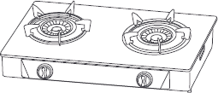





|  |  |
| --- | --- |
|  |  |
|  |  |
|  |  |
|  |  |
|  |  |
|  |  |
|  |  |
|  |  |
|  |  |
|  |  |
|  |  |
|  |  |
|  |  |
|  |  |
|  |  |
|  |  |
|  |  |
|  |  |
|  |  |
|  |  |
|  |  |
|  |  |
|  |  |
|  |  |
|  |  |
|  |  |
|  |  |
|  |  |
|  |  |
|  |  |
|  |  |
|  |  |
|  |  |
|  |  |
|  |  |
|  |  |
|  |  |
|  |  |
|  |  |
|  |  |
|  |  |
|  |  |
|  |  |
|  |  |
|  |  |
|  |  |















# 





СРОК СЛУЖБЫ ТОВАРА - НЕ МЕНЕЕ 3 ЛЕТ





    
    
    
    

